News Release

OPC UA Companion Standard for Sercos released
Scottsdale, July 19, 2017 - The OPC Foundation and Sercos International announce that the Sercos OPC UA Companion Specification Release is now available. This specification describes the mapping of the Sercos® device model and the Sercos device profiles to OPC UA, so that functions and parameters of Sercos devices are made accessible via OPC UA in a vendor-independent manner. This initiative aims at simplifying the communication between machine periphery and supervisory IT systems and to support the requirements of Industrie4.0 regarding semantic interoperability. The OPC Foundation and Sercos International started their collaboration with the common aim to improve the machine integration and to simplify the communication between machine periphery and higher-level IT systems.
“Sercos provides a very rich robust device model and device profiles that made logical sense to plug into an OPC UA namespace. The Sercos OPC UA Companion Specification enables machine to machine interoperability, and machine integration with the cloud-based applications at a minimum. Sercos suppliers will now be able to take advantage of the rich service oriented architecture of OPC UA, truly facilitating the vision of the embedded world having information integration into the cloud. The OPC community will now be able to be easily extend their products to support the great networking technology of Sercos. Both organizations are working together to facilitate and help the suppliers bring certified products to the marketplace supporting this new companion specification”, says Thomas J. Burke, OPC Foundation President and Executive Director.
“In today’s manufacturing systems automation devices & systems from many different manufacturers have to be integrated and maintained, resulting in significant total cost of ownership (TCO) during the entire product life cycle. At the same time product planning and control require process and machine related information to facilitate the efficient use of the manufacturing resources. This challenge can be faced best with a standardized mapping which brings together the well-defined semantics of Sercos with the OPC UA Sercos information model. Use cases cover a broad range from device parametrization and network configuration up to energy management and preventive maintenance. Furthermore new business models can be easily implemented because users and suppliers can rely on a consistent and vendor-independent semantic”, states Peter Lutz, Managing Director of Sercos International.
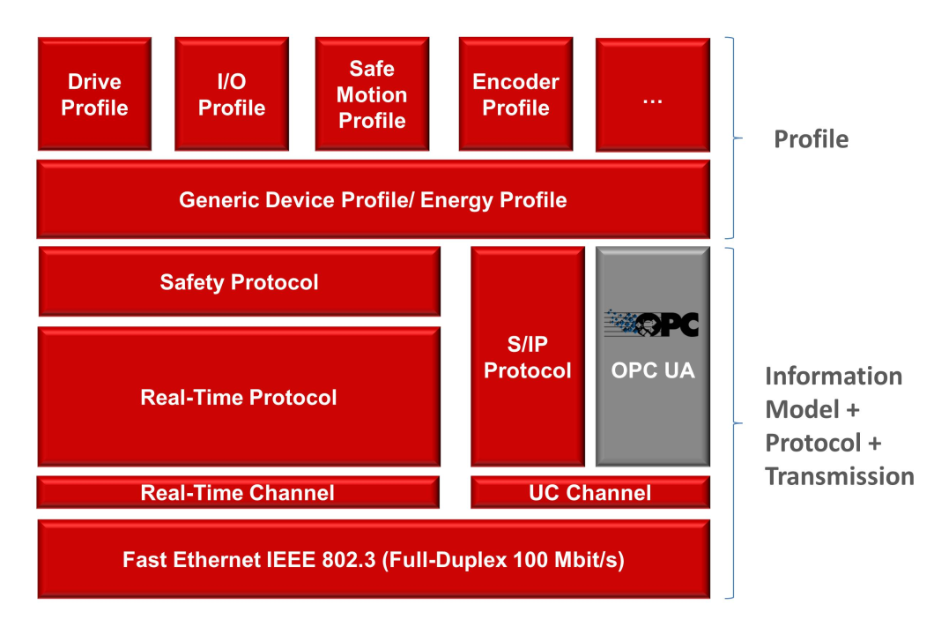
Figure 1: Inclusion of OPC-UA in the Sercos system architecture
The mapping rules specified by Sercos can be used for different implementation approaches. On the one hand, the OPC UA server functionality can be implemented in a Sercos master device (e.g. CNC or PLC). On the other hand, it is possible to transfer this functionality to a Sercos slave device. In the latter case, the OPC UA accesses are executed in parallel to the Sercos real-time communication or even without any Sercos real-time communication. Thus, a consistent communication with OPC UA down to the field level is possible without abandoning the hard-real-time communication of the Sercos automation bus.

About Sercos International
Sercos International is an association of users and manufacturers that is in charge of technical development, standardization, certification and marketing for the Sercos automation bus. Conformance tests guarantee that Sercos implementations are standard-compliant ensuring that devices from different manufacturers can be combined. Based in Germany, the organization presently has more than 90 member companies located around the world and has national liaison offices in North America and Asia.

About Sercos
The SErial Realtime COmmunication System, or Sercos, is one of the world’s leading digital interfaces for communication between controls, drives and decentralized peripheral devices. Sercos has been used in machine engineering for approximately 25 years and is implemented in over 5 million real-time nodes. With its open, manufacturer-independent Ethernet-based architecture, Sercos III is a universal bus for all automation solutions.

For further information, please visit: www.sercos.org

About OPC Foundation
The OPC Foundation is a nonprofit international standards organization dedicated to developing and maintaining the best specifications, technology, process and certification to achieve multivendor multiplatform secure reliable information integration interoperability from the embedded world to the cloud. OPC Foundation started in 1995, and the OPC community is made up of over 4200 different companies building OPC Products with over 45,000,000 installations. OPC Foundation defines open, OPC specifications are available without membership, OPC reference implementations are open sourced on GitHub, and the foundation has an open certification program enabling members and nonmembers to certify their products.

About OPC UA
OPC Unified Architecture (OPC UA) is a platform and vendor independent communication technology for a secure and reliable data exchange over the different levels of the automation pyramid. In addition, the information models of the OPC UA standard provide the foundation for a semantic interoperability.
For more information, please visit: www.opcfoundation.org

Contacts

Peter Lutz, Managing Director
Sercos International e. V.
Phone +49-7162-94 68-65
Email: p.lutz@sercos.de

Stefan Hoppe, Global Vice President
OPC Foundation
Phone: +49 5246 963 4533;
E-mail: stefan.hoppe@opcfoundation.org

